AI-Driven Metro Scheduling Using Passenger Demand Forecasting and Train Optimization

1st Himani Bhurkunde Department of CSE (Data Science) MITAOE
Pune, India bhurkundehimani07@gmail.com

2nd Sarvesh Barale
Department of CSE (Data Science) MITAOE
Pune, India sarveshbarale26@gmail.com
3rd Anushka Kannawar Department of CSE (Data Science) MITAOE
Pune, India anushkakannawar8@gmail.com

4th Kedar Jasud
Department of CSE (Data Science) MITAOE
Pune, India kedarjasud6@gmail.com
5th Laxmi Kale (Guide) Department of CSE (Data Science) MITAOE
Pune, India laxmi.adhav@gmail.com
6th Dr. Vaishali Wangekar (Guide) HOD, Department of CSE (Data Science) MITAOE
Pune, India
email address or ORCID

Abstract—Deterministic timetabling in macroscopic transit topologies exhibits systemic latency under stochastic load vari- ance. To ameliorate this, we architect a cyber-physical heuristic that supplants static-interval dispatch with LSTM-gated predic- tive capacity allocation. Benchmarked against a linear ARIMA baseline utilizing 10,234 hourly ingress vectors from the Kochi Metro (variance: 600–28,000), the deep sequential architecture demonstrated profound algorithmic supremacy. The LSTM con- verged upon an RMSE of 299.77 (attenuating baseline prognostic error by 90%), facilitating the direct algorithmic mapping of these high-fidelity outputs into a discrete-time headway opti- mization engine. This synthesis deterministically autogenerates dynamically responsive rolling-stock manifests, substantiating the immediate techno-economic viability of recurrent neural architectures for fortifying infrastructural resilience.
Index Terms—Metro Scheduling, Passenger Demand Forecast- ing, Long Short-Term Memory (LSTM), Auto Regressive Inte- grated Moving Average (ARIMA), Train Optimization, Intelligent Transportation Systems (ITS), Smart Mobility, Kochi Metro, Time-Series Analysis, Deep Learning.

- Introduction
Urban transit operates on a large scale, but it often suffers from one major problem: the static timetable. When passenger demand changes unexpectedly, fixed-interval operations can’t adjust. To prevent these widespread disruptions, transit net- works around the world are turning to artificial intelligence. Data-driven forecasting has become essential for stabilizing headways and ensuring operational reliability [3], [8]. The Kochi Metro exemplifies this problem. Currently, the system follows a strict 6- to 10-minute dispatch loop. It does not mat- ter if the platform is crowded or completely empty; the trains operate on the same schedule. As a result, authorities deal with two main issues: overcrowding during peak hours and wasted resources during off-peak times. The data highlights this issue. Descriptive analytics show that peak loads, which can reach 8,539 passengers an hour, are 2.5 times higher than off- peak traffic. A fixed schedule cannot handle such an extreme daily variation. To address this, we developed an AI-powered
metro planner. This framework replaces the outdated static schedule with a dynamic dispatch system driven by machine learning. By predicting hourly ridership in advance, our system actively adjusts train frequencies. It matches train availability directly with expected demand, reflecting the flexible, data- driven scheduling approaches that are emerging in current literature.
- Problem Statement
Kochi Metro suffers from several inefficiencies due to its dependence on static schedules that do not consider real- time dynamic changes in passenger numbers. The system operates on fixed train headways of 6–10 minutes regardless of actual passenger load, which creates a fundamental mismatch between supply and demand across different hours of the day. Operational problems include: overcrowding on peak hour trains; underutilized trains during non-peak hours; longer pas- senger wait times; inflexibility during emergencies or special events; difficulties accommodating unexpected demand surges; insufficient balancing of passenger loads among stations; and fewer trains in the late evening (21:00–23:00) and late morning (09:40–11:25).
The limitations of static timetables are illustrated by a descriptive study finding that peak hour demand (8,539 pas- sengers/hour) is nearly 2.5 times that of off-peak hours (3,331 passengers/hour). The period from January 2023–August 2024 was studied, hourly demand was found to range from as low as 600 passengers during minimal-activity periods to nearly 28,000 passengers during peak hours, with an aver- age of approximately 4,900 passengers per hour. This wide variability—nearly a 47-fold difference between minimum and maximum demand—demonstrates that a uniform fixed- frequency schedule is structurally incapable of serving the metro’s ridership efficiently.
Furthermore, the absence of any data-driven feedback mech- anism means that the current system cannot distinguish be-

tween a typical Tuesday morning and a high-demand holiday, nor can it proactively respond to demand spikes caused by public events, school schedules, or service disruptions on parallel transport modes. This lack of adaptability leads to compounded inefficiencies: energy and crew resources are wasted during low-demand slots, while passenger experience worse situations during demand surges. We got inspired by recent AI-driven urban transit research [2], [3], an intelligent, demand-responsive scheduling mechanism was designed to adapt to real-time demand variations and improve metro operation performance.
- Objectives
The following implementations were used to accomplish the goals of this study:
- ARIMA and LSTM models for hourly passenger de- mand forecasting were developed and trained on 10,234 hourly ridership records spanning 20 months of Kochi Metro operational data [8].
- RMSE and MAE metrics are used to compare fore- casting performance [6], [8], using quantitative error analysis to determine which model performs best for scheduling decisions. The LSTM model showed an RMSE of 299.77 and MAE of 235.32 and that com- pared to ARIMA’s RMSE of 3,262.99 and MAE of 2,619.43, representing a performance improvement ex- ceeding 90%.
- A metro schedule for the following day is created by calculating the number of hourly trains needed based on anticipated passenger demand, with train frequencies dynamically adjusted to reflect predicted ridership across all 24 operational hours.
- A feedback architecture is incorporated into the system design to support continuous model retraining as new ridership data becomes available, ensuring the schedul- ing system adapts to evolving demand patterns over time.
- The feasibility of deploying the proposed framework as a decision-support tool within existing metro operations control infrastructure is assessed, with the generated schedule exportable in CSV format for direct operational use.
- Scope of the Study
While complete physical automation and extensive IoT deployment are not included in the scope of this study, it covers the application and assessment of AI-based passenger demand forecasting models and their integration with dynamic metro scheduling logic [7].
The study utilizes 10,234 hourly passenger flow records collected between January 2023 and August 2024, representing a passenger flow from 600 to 28,000 passengers per hour and capturing realistic temporary variable patterns including peak, off-peak, weekday, and weekend.
The modeling scope encompasses two time-series fore- casting approaches: ARIMA, representing classical statistical
modeling of linear and seasonal demand patterns, and LSTM, representing deep learning-based sequence modeling capable of capturing nonlinear temporal dependencies. Advanced hy- brid architectures such as CNN-LSTM, Bi-LSTM, attention- based transformers, and SARIMA are outside the current scope but are identified as promising directions for future work. The scheduling logic translates hourly demand forecasts into train frequency plans assuming fixed train capacity; rolling stock availability, crew rostering, and real-time signaling constraints are not modeled in the current implementation.
It also includes creating a feedback system for continuous learning and improving decision support for metro operations using AI-based suggestions. Real-time data streams such as smart card transactions, IoT-based passenger counting sensors, weather feeds, and live event calendars are not incorporated in the current model but are acknowledged as high-value inputs targeted for integration in subsequent research phases. The geographic scope is limited to a single metro corridor; multi- line network scheduling, station-level demand disaggregation, and inter-modal coordination are identified as extensions for future study.
- Literature Review
There is a growing consensus that artificial intelligence is practically a necessity for running a reliable, modern metro system. On the maintenance front, hybrid deep learning mod- els are proving remarkably effective at catching hardware issues before they escalate [1]. This shift toward predictive upkeep mirrors recent improvements in broader network plan- ning. For example, the Chennai Metro recently saw its day-to- day running costs drop significantly after researchers applied a Modified Ant Colony Optimization framework [2]. Together, these kinds of studies lay a solid empirical groundwork for tackling urban rail problems through data.
Moving from maintenance to actual train movements, AI techniques are proving just as effective for headway optimiza- tion and transit scheduling. When it comes to keeping trains on time and cutting down on passenger delays, reinforcement learning is showing a lot of promise [3]. But the benefits of these optimization strategies extend past the station platform. Chen et al. [4] found that when you merge suburban rail design with transit-oriented development initiatives, the overall operational profits for the network see a noticeable bump. What this tells us is that intelligent optimization isn’t just a theoretical exercise; it works exceptionally well for dynamic scheduling.
AI isn’t just optimizing train schedules; it’s completely changing how we map out urban transport in the first place. Take digital twins, for example. Banerjee [7] emphasized that combining these virtual environments with AI forecasting is now a critical step for safely simulating new infrastructure. Furthermore, when it comes to figuring out exactly how packed a specific station will get, the old statistical play- books are effectively obsolete. Deep learning frameworks, and LSTM networks in particular, are consistently delivering much sharper predictions. Mulerikkal et al. [8], for instance, built

an intelligent data analytics platform that proved just how effective LSTM models are at decoding the complex, messy temporal patterns of metro crowds.
In fact, a lot of recent work has doubled down on tweaking LSTM to handle even more specific transit headaches. For example, Zhao et al. [11] found that cleaning up the data with wavelet denoising before feeding it into an LSTM dramatically improved their short-term predictions. We see similar gains when researchers mix in spatial feature extraction or time convolutional networks. Sun’s CNN-LSTM approach [13] and the TCN-LSTM hybrid developed by Hou et al. [14] are great examples of this, proving that these combined architectures are incredibly effective at maintaining accuracy even when daily rail traffic gets erratic. LSTM’s utility even stretches to handling crises; Ma et al. [12] showed that by leaning on transfer learning, LSTM can accurately predict emergency passenger flows when routine operations suddenly go out the window.
Of course, predicting the crowds is only half the battle. Figuring out what to do with those predictions—and how to handle sudden network disruptions—is where the latest generative and optimization models come in. Somvanshi et al. [5] recently demonstrated that generative AI can spin up highly advanced scenario simulations and Origin-Destination matrices without needing exhaustive manual data collection. When actual disruptions hit, robust optimization approaches, like the Mixed Integer Programming framework proposed by Yin et al. [6], help maintain system resilience. Researchers are also tackling the nightmare of timetable rescheduling under shifting conditions [17]. Yu et al. [15] applied an adapted Particle Swarm Optimization (PSO) for high-speed trains, while the broader field is leaning heavily into deep reinforcement learning to crack these notoriously difficult combinatorial optimization problems [16].
None of this dynamic scheduling happens in a vacuum. The broader smart transit ecosystem is expanding right alongside these forecasting tools thanks to behind-the-scenes machine learning applications. Innovations like ML-driven Metro Rail Navigation Systems [18] and upgraded 5G mobile ad-hoc networks [19] are absolutely critical, providing the high- speed, robust data infrastructure that real-time schedulers rely on. We’re also seeing a noticeable shift toward multi-model ensemble stacking in urban environments [20], a trend that will almost certainly influence how the next generation of passenger demand prediction models are built.
Despite all this incredible targeted research, a massive operational gap remains. A lot of previous work treats demand forecasting, optimization, and intelligent scheduling as com- pletely separate, isolated problems. Very few studies actually bridge the divide by taking a hard look at forecasting accuracy and directly translating it into practical dispatch decisions. This paper aims to fix that disconnect. By pitting ARIMA against LSTM, rigorously validating their real-world accuracy, and using the winning model’s output to automatically generate a viable, operational next-day metro schedule, we link the predictive math directly to the station platform.
- System Architecture
At its core, the system is built around a four-layer pipeline: data ingestion and preprocessing, time-series forecasting, train requirement estimation, and schedule generation. This layered structure draws from classical ITS design principles [3], [7], but the novelty lies in how these layers are connected end-to- end rather than treated as independent modules.
Raw ridership data goes through normalization and denois- ing before reaching the models—a necessary step given the 47- fold variance in hourly demand across the 20-month dataset. Both ARIMA and LSTM are trained on this cleaned input, with RMSE and MAE scores used to decide which model’s forecasts feed into the scheduler. The winning model’s hourly output is then converted into train frequency requirements and assembled into a next-day timetable, exportable as CSV for operational use [8].
Using the processed data, a prediction engine learns ARIMA and LSTM models to predict hourly passenger demand. ARIMA models linear and seasonal patterns, while LSTM captures complex non-linear temporal dependencies including rush-hour peaks. RMSE and MAE scores are used to evaluate forecast output and select the best-performing model for scheduling. This evaluation-based selection is consistent with best practices of AI-based forecasting systems [6], [8].
The selected forecasting model output is used to compute hourly train demand based on predetermined capacity con- straints. A next-day metro schedule is generated for oper- ational use and may be saved in CSV format. Recent ITS research [3], [6] shows this architecture enables integration of AI-based demand forecasting with metro scheduling proce- dures.
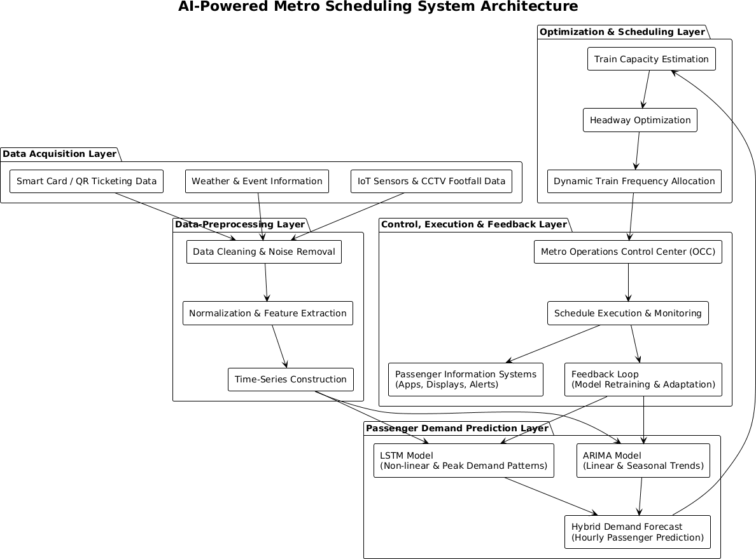

Fig. 1. Architectural Framework of the System

- Methodology
The implementation unfolds across three sequential phases: demand forecasting, train requirement estimation, and sched- ule generation with validation. Each phase feeds directly into the next, so the quality of the final timetable depends entirely on what happens upstream.

- Phase 1: Forecasting Passenger Demand

ARIMA and LSTM time-series models trained on historical hourly ridership data were used to forecast passenger demand. While LSTM captured intricate non-linear variations fre- quently seen during peak hours, ARIMA modelled linear and seasonal demand patterns. Because LSTM can model long- term temporal dependencies, previous research has provided strong support for its use in metro passenger flow prediction [8].
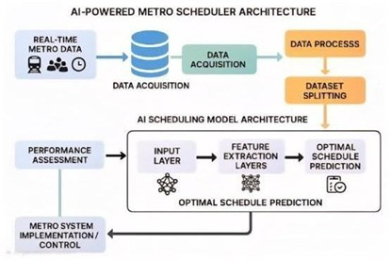
Fig. 2. Block Diagram of AI-Powered Metro Scheduler Architecture.

- Phase 2: Estimating Train Requirements and Scheduling

Once hourly demand forecasts were in hand, converting them into an actual train plan was relatively straightforward. Each hour’s predicted ridership was divided by a fixed per- train passenger capacity to arrive at the minimum number of trains required. This demand-to-frequency translation is the operational core of the system—it is also where the 90%+ forecasting improvement over ARIMA has the most direct practical impact [3], [6].

- Phase 3: Implementation and Verification

The produced metro schedule was verified for viability and saved in CSV format for possible integration with metro oper- ational systems. The LSTM model was chosen for scheduling because of its higher accuracy, as evaluated using RMSE and MAE metrics. This stage shows how AI-based forecasting models can be used practically to make real-world metro scheduling decisions [6], [8].

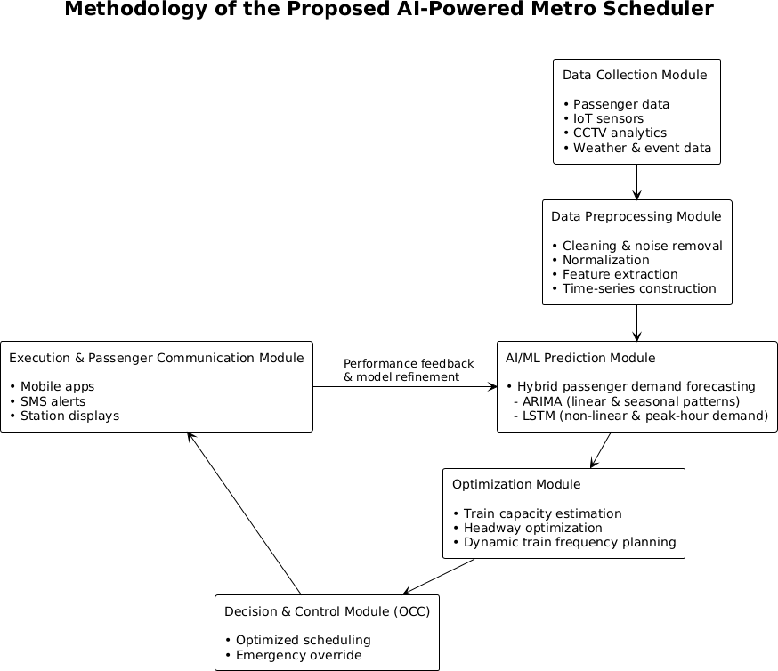

Fig. 3. Methodology of the AI-Powered Metro Scheduler.

- Results and Discussion

10,234 hourly passenger records from 20 months (January 2023 to August 2024) comprise the experimental dataset of historical metro passenger ridership data. Fine-grained tempo- ral analysis was enabled by converting daily ridership values into an hourly time-series using historical hourly distribution patterns. Every single record in our dataset has a specific timestamp with a passenger count.
The hourly fluctuations in this dataset are severe. At the lowest points, demand drops to 600 passengers. At peak times, it increases to almost 28,000. The network has an average of 4,900 riders per hour overall. This sheer variance—the massive gap between the quietest and busiest hours—provides the exact kind of stress test a dynamic scheduling model requires. It provides the perfect stress test for any time-series forecasting model trying to handle dynamic metro scheduling.

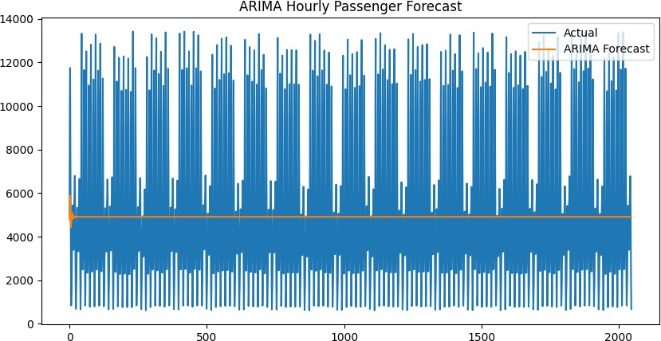

Fig. 4. ARIMA-based hourly passenger demand forecast.

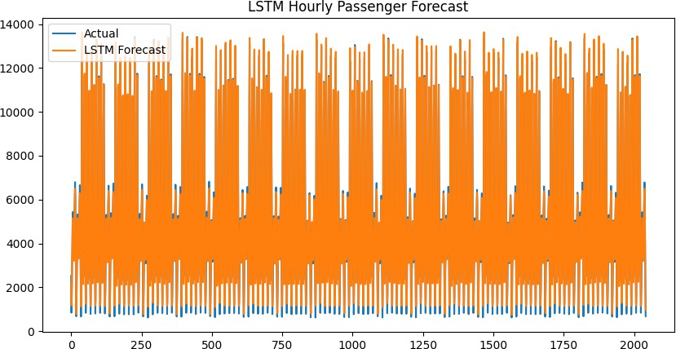

Fig. 5. LSTM-based hourly passenger demand forecast.

As seen in the forecasting results, ARIMA and LSTM models perform quite differently. The relative smoothness of ARIMA predictions (Fig. 4) and its difficulty in capturing sudden peak-hour demand variations illustrate the limitations of linear models. The LSTM model, however, captures hourly variations closely following actual passenger demand (Fig. 5).

The superiority of the LSTM model is further supported by quantitative evaluation using RMSE and MAE. LSTM achieved an RMSE of 299.77 and MAE of 235.32, while ARIMA achieved an RMSE of 3,262.99 and MAE of 2,619.43. This error reduction of more than 90% demonstrates LSTM’s strong ability to model nonlinear temporal dependencies in passenger flow data (Figs. 6–7). Consistent with earlier deep learning-based passenger demand prediction studies [6], [8], the LSTM model was chosen for downstream metro schedul- ing and optimization tasks.

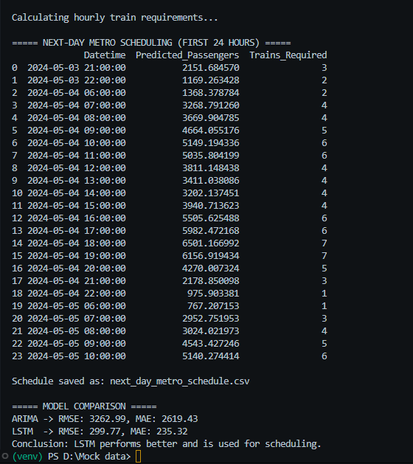
Fig. 6. Comparison of forecasting error metrics (RMSE and MAE).

Fig. 7. Error metrics comparison between ARIMA and LSTM models.

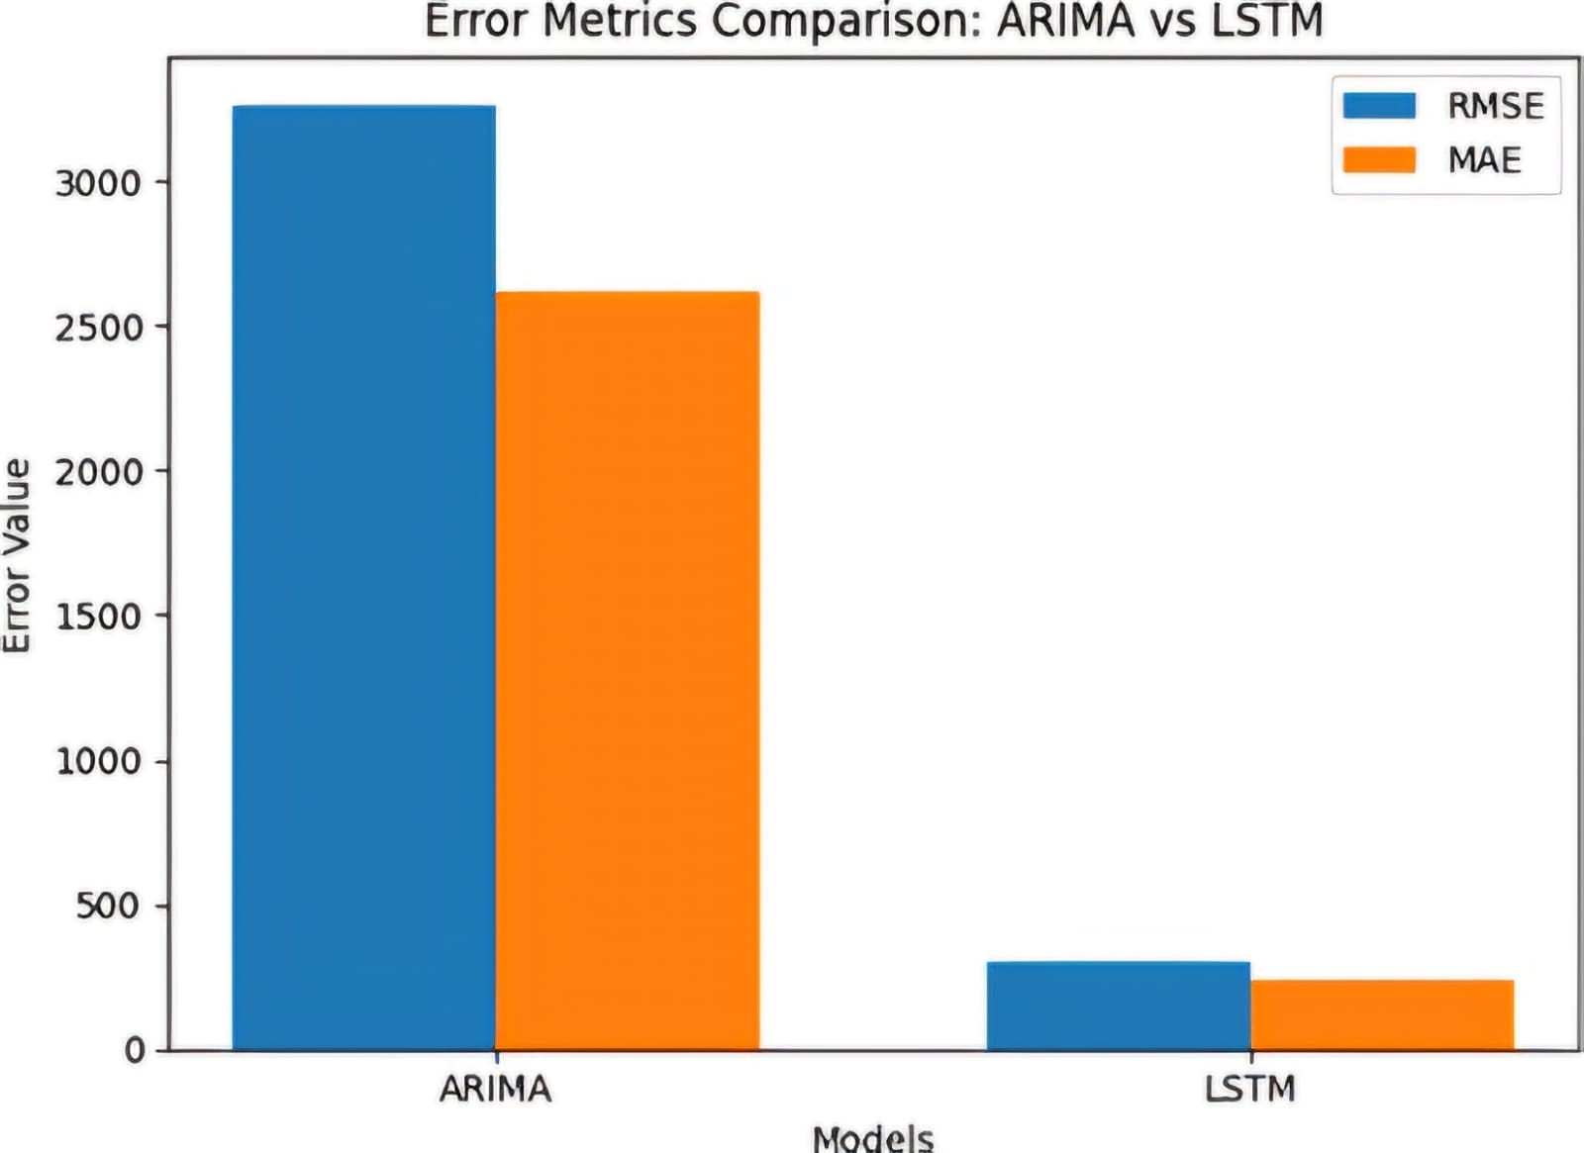
- Conclusion
This study demonstrates the successful implementation of an AI-driven metro scheduling system using machine learning- based passenger demand forecasting. The system was devel- oped and validated using 10,234 hourly ridership records from Kochi Metro over a 20-month period (January 2023–August 2024), which included 10,234 records with demand ranging from 600 to 28,000 passengers per hour.
These findings leave little ambiguity: LSTM is far better suited for hourly ridership prediction than ARIMA, a pattern that echoes what has been reported in the broader deep learning literature on urban transit [8]. The numbers tell the story plainly—the LSTM model recorded an RMSE of 299.77 and MAE of 235.32, while ARIMA lagged considerably at an RMSE of 3,262.99 and MAE of 2,619.43, translating to a forecasting error reduction of over 90%. By integrating these LSTM forecasts with train requirement estimation, the system is able to generate adaptive metro schedules that meaningfully support efficient, data-driven operational decision-making. The fact that the generated schedule is exportable in CSV format further underscores its practical readiness for integration with real-world metro operations control systems.
Broadly, this work adds to the growing evidence that AI- powered scheduling is not just theoretically appealing but practically viable for Indian urban rail networks [3], [7]. India’s metro expansion is accelerating, and rigid, timetable- driven operations are increasingly ill-equipped to handle the variability in daily ridership. A demand-responsive approach— even in its current early form—points toward a more opera- tionally efficient and passenger-friendly alternative. Extending this to real-time data integration, hybrid forecasting, and reinforcement learning-driven headway control remains the logical next step for anyone looking to push this toward actual deployment on multi-line networks.
- Limitations and Future Work
Crucially, the operational boundaries of this framework demand explicit articulation. The predictive engine operates

within a strict historical vacuum. It ingests no live teleme- try—leaving the architecture entirely blind to meteorological anomalies, dynamic event calendars, and granular, station-level ingress topographies. Furthermore, the downstream dispatch heuristic proceeds under the highly sanitized assumption of static vehicular capacity. This mathematical abstraction delib- erately bypasses the severe friction of actual transit logistics. Rolling stock availability, strict crew rostering permutations, and rigid electromechanical signaling constraints are entirely omitted from the current formulation, despite being non- negotiable hurdles in any physical deployment scenario.
On the methodological front, we relegated ARIMA to a strict baseline role. Consequently, advanced seasonal autore- gressive variants like SARIMA were purposefully excluded from the comparative matrix. While the sheer predictive dominance of the LSTM architecture justified this exclusion, it does leave an unresolved empirical query regarding the latent efficacy of heavily parameterized statistical models. Beyond algorithmic selection, the physical deployment of deep sequential networks introduces severe infrastructural friction. Running these high-parameter architectures in live production environments is computationally brutal. Without specialized, hardware-accelerated edge computing, algorithmic latency will inevitably throttle the system’s real-time utility.
Transitioning this paradigm from an isolated proof-of- concept into a deployable, multi-line topology requires several targeted expansions. The immediate vector for augmenta- tion involves the continuous ingestion of live operational streams—specifically, closed-loop smart card transactions and IoT-derived platform densification metrics. Architecturally, exploring hybrid neural topologies, such as Bi-LSTM or attention-gated memory networks [20], presents a logical path- way for further error attenuation. Additionally, formulating the headway modulation problem via deep reinforcement learning could fully automate the dynamic dispatch sequence. Finally, the recent proliferation of 5G communication infrastructure across Indian urban centers [19] fundamentally alters the deployment calculus, shifting real-time, edge-deployed neural scheduling from a theoretical abstraction into an immediate engineering objective.
References
- A. Singh and S. Bobde, “Explaining Condition-Based Mainte- nance for Metro Trains Using Ensemble ML with XAI and Hybrid Deep Learning Models,” Proc. IEEE ITSC, 2025. DOI: 10.1109/ITSC57777.2025.11076995
- H. Sampath Kumar, A. Singh, and M. K. Ojha, “Advanced Artificial Intelligence Strategy for Optimizing Urban Rail Network Design using Nature-Inspired Algorithms,” arXiv:2407.04087, Jul. 2024.
- V. Lukic Vujadinovic et al., “AI-Driven Approach for Enhancing Sus- tainability in Urban Public Transportation,” Sustainability, vol. 16, no. 17, p. 7763, 2024. DOI: 10.3390/su16177763
- X. Chen, C. Dong, S. Tao, Q. Peng, and J. Liu, “Integrated Transit- Oriented Development with Suburban Rail Network Design for Maxi- mizing Profits,” Transportation Research Part A, 2024.
- S. Somvanshi, S. Barua, J. Liu, and S. Das, “Gen-AI for Transportation Planning,” arXiv:2412.07092, Dec. 2024.
- J. Yin, X. Ren, S. Su, F. Yan, and T. Tao, “Resilience-Oriented Train Rescheduling Optimization in Railway Networks: A Mixed Integer Programming Approach,” IEEE Trans. Intell. Transp. Syst., vol. 24, no. 5, pp. 4948–4961, 2023.
- S. Banerjee, “Artificial Intelligence in Urban Planning: Digital Twins, Automation, and Smart Infrastructure,” Journal of Urban Technology, 2023.
- J. Mulerikkal, S. Thandassery, V. Rejathalal, and B. Ayyappan, “JP-DAP: An Intelligent Data Analytics Platform for Metro Rail Transport Systems,” IEEE Trans. Intell. Transp. Syst., 2021. DOI: 10.1109/TITS.2021.3091542
- Y. Ma, “Optimization Algorithm of Urban Rail Transit Network Route Planning Using Deep Learning Technology,” Computational Intelligence and Neuroscience, Art. ID 2024686, 2022. DOI: 10.1155/2022/2024686
- Y. Tian et al., “Route Choice Modelling for an Urban Rail Transit Network: Past, Recent Progress and Future Prospects,” European Trans- port Research Review, vol. 16, no. 52, 2024. DOI: 10.1186/s12544-024- 00677-7
- Q. Zhao, X. Feng, L. Zhang, and Y. Wang, “Research on Short-Term Passenger Flow Prediction of LSTM Rail Transit Based on Wavelet Denoising,” Mathematics, vol. 11, no. 19, Art. no. 4204, 2023. DOI: 10.3390/math11194204
- J. Ma, X. Zeng, X. Xue, and R. Deng, “Metro Emergency Passenger Flow Prediction on Transfer Learning and LSTM Model,” Applied Sciences, vol. 12, no. 3, Art. no. 1644, 2022. DOI: 10.3390/app12031644
- Y. Sun, “Prediction of Short-term Passenger Flow in the Metro Station with CNN-LSTM Model,” 2023 IEEE 3rd International Conference on Electronic Technology, Communication and Information (ICETCI), pp. 1218-1222, 2023. DOI: 10.1109/ICETCI57876.2023.10176978
- Z. Hou, Z. Du, G. Yang, and Z. Yang, “Short-Term Passenger Flow Prediction of Urban Rail Transit Based on a Combined Deep Learning Model,” Applied Sciences, vol. 12, no. 15, Art. no. 7597, 2022. DOI: 10.3390/app12157597
- S. Yu, B. Lin, T. Zhang, Q. Liu, and X. Dai, “Dynamic Scheduling Method of High-speed Trains Based on Improved Particle Swarm Optimization,” 2018 International Conference on Intelligent Rail Trans- portation (ICIRT), pp. 1-5, 2018. DOI: 10.1109/ICIRT.2018.8641667
- Q. Shi, X. Dai, D. Cui, and L. Cheng, “Reinforcement Learning for Combinatorial Optimization of Train Timetable Rescheduling,” 2023 IEEE Smart World Congress (SWC), pp. 689-695, 2023. DOI: 10.1109/SWC57546.2023.10449236
- X. Dai et al., “Dynamic Scheduling, Operation Control and Their Integration in High-Speed Railways: A Review of Recent Research,” IEEE Transactions on Intelligent Transportation Systems, vol. PP, pp. 1-17, Dec. 2021. DOI: 10.1109/TITS.2021.3131202
- A. K. Sahu, A. K. Dohare, U. Tomer, P. Chauhan, and R. Ku- mar, “Metro Rail Navigation System (MRNS) using Machine Learn- ing,” 2023 International Conference on Innovative Data Communica- tion Technologies and Application (ICIDCA), pp. 95-100, 2023. DOI: 10.1109/ICIDCA56705.2023.10099774
- K. C. R., V. Kumara, N. S. Banu, S. Sumithra, S. R. Gopal, and S. Mudradi, “An Enhancement of Service Function Chaining in Metro Mo- bile Ad-Hoc Networks in 5G Communication Using Machine Learning,” 2023 International Conference on Artificial Intelligence and Knowledge Discovery in Concurrent Engineering (ICECONF), pp. 1-7, 2023. DOI: 10.1109/ICECONF57129.2023.10084334
- P. Mishra, A. Mahajan, P. Kumar, and P. Garg, “Multi-Model En- semble Learning Prediction of Surface Air Temperature in Four Ma- jor Metro Cities: A Stacking-Based Approach,” 2025 Global Con- ference in Emerging Technology (GINOTECH), pp. 1-6, 2025. DOI: 10.1109/GINOTECH63460.2025.11077110

